**Ideate for India**

**Plant Disease Classifier**

**Category - Agriculture**

The Plant Disease Classifier (PDC) is aimed at farmers. Its main application is to classify the following 24 plant leaf diseases:

|  |  |
| --- | --- |
| Plant | Disease |
| Apple | 1. Apple Scab 2. Black Rot 3. Cedar Apple Rust |
| Cherry | 1. Powdery Mildew |
| Corn/ Maize | 1. Cercospora leaf spot 2. Common Rust 3. Northern Leaf Blight |
| Grape | 1. Black Rot 2. Esca (Black Measles) 3. Isariopsis Leaf Spot |
| Peach | 1. Bacterial spot |
| Pepper | 1. Bacterial Spot |
| Potato | 1. Early Blight 2. Late Blight |
| Strawberry | 1. Leaf Scorch |
| Tomato | 1. Bacterial Spot 2. Early Blight 3. Late Blight 4. Leaf Mold 5. Septoria Leaf Spot 6. Spider Mites 7. Target Spot 8. Tomato Mosaic Virus 9. Tomato Yellow Leaf Curl Virus |

**About This Project**

For this project we will be doing Image Classification by building a Convolutional Neural Network (Deep Learning) using TensorFlow and Keras via Python programming language. We will be using the PlantVillage Plant Disease dataset for our project. The link to the dataset is provided below:

<https://github.com/spMohanty/PlantVillage-Dataset/tree/master/raw/color>

The following libraries will be used:

* Opencv
* TensorFlow
* Keras
* Tqdm
* Pickle
* Matplotlib
* NumPy
* SciPy
* Pandas
* Tkinter

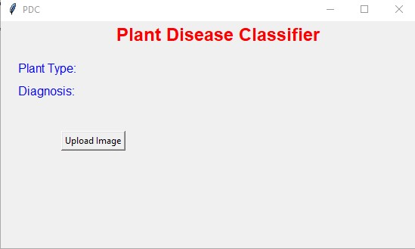

The Plant Disease Classifier GUI

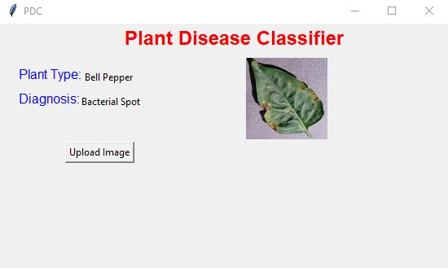

The Plant Disease Classifier predicting Bell Pepper leaf with Bacterial Spot from leaf image only.

Other References:

<https://arxiv.org/abs/1511.08060>